MINISTRY OF EDUCATION AND SCIENCE OF UKRAINE

NATIONAL TECHNICAL UNIVERSITY   
“KHARKIV POLYTECHNIC INSTITUTE”

Department of Software Engineering and Management Information Technology

REPORT

on laboratory work # 6

on the discipline

“python frameworks”

Executed by

Student of the group KN-218g.e

Karyna OHOL

Checked by

Ass. Prof. of department “SEMIT”

Svitlana KOVALENKO

Kharkiv 2020

Working with Strings in Pandas

**Objectives**

**Goal: Learning Pandas features for working with string data.**.

**Tasks**

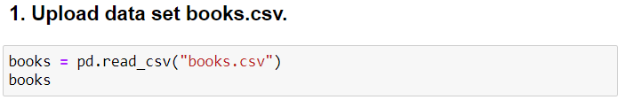

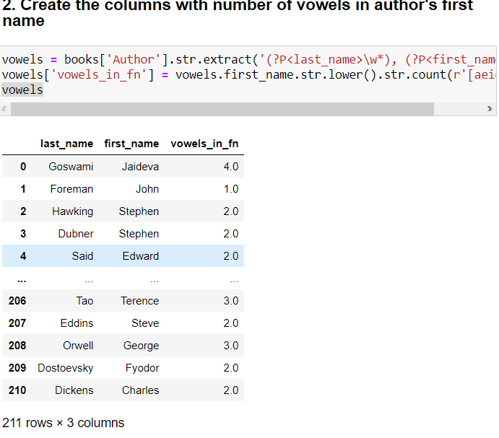

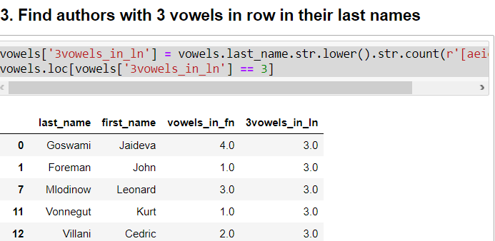

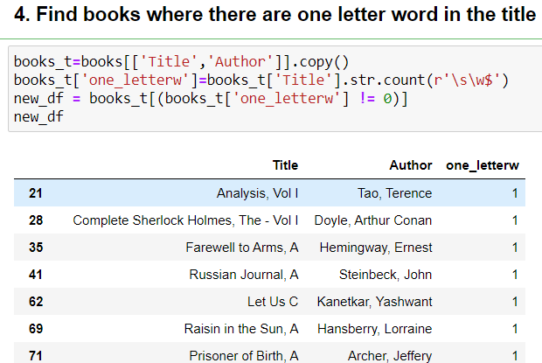

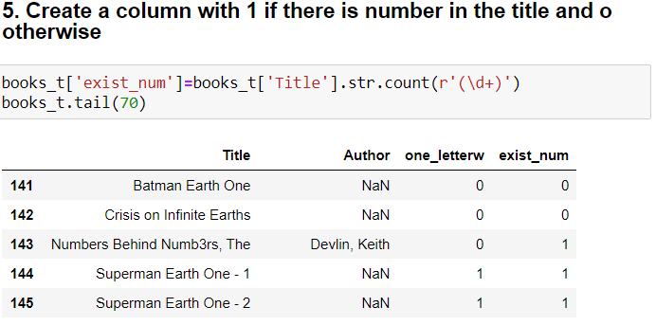

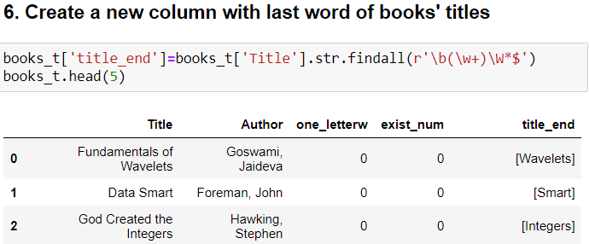

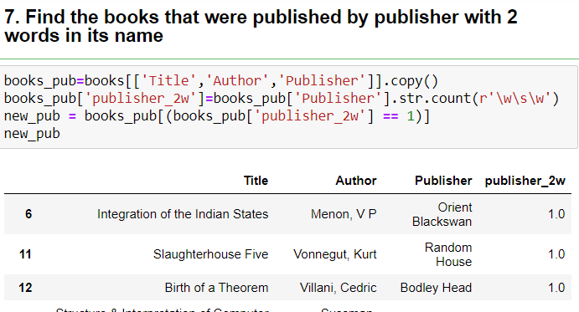

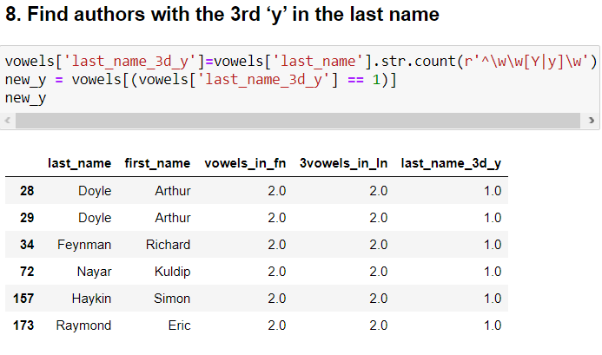

**Conclusions**

To conclude, during today’s laboratory training some possibilities to create and modify text using pandas library and RegEx were discovered and tested. Moreover, some pyplot features were also revised. A RegEx, or Regular Expression, is a sequence of characters that forms a search pattern. RegEx can be used to check if a string contains the specified search pattern.